Docker volumes:

Create volume:

docker volume create name

view volume:

docker volume inspect name

delete volume:

docker volume rm name

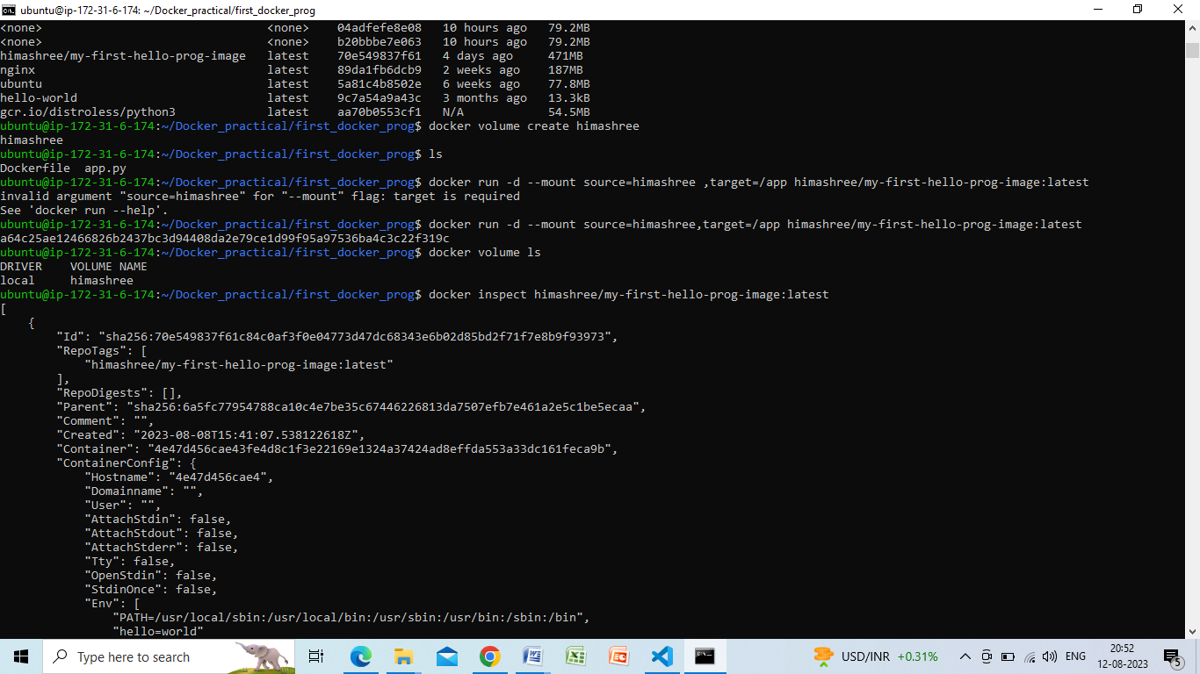

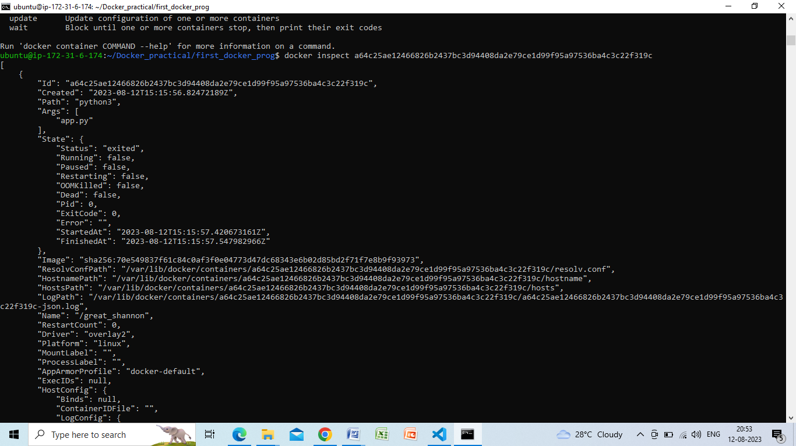

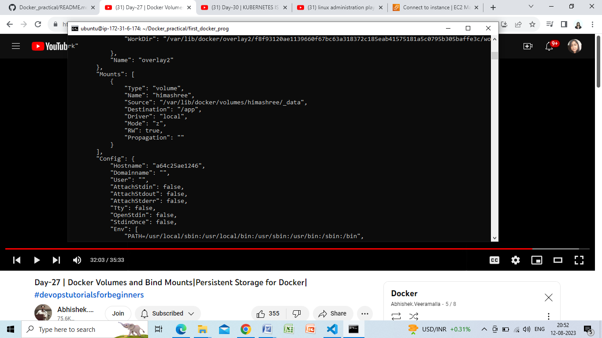

The volume is attached